 | Se |  |  | Keep Track of your Practicing
:

Concerts
How many Days have you Practiced?
PRACTICE
Bring music and binder to class
Music is a universal language

 | SEPTEMBER 2020
 | Monday | Tuesday | Wednesday | Thursday | Friday | Saturday | Sunday
Week 5  Week 4  Week 3  Week 2  Week 1 | 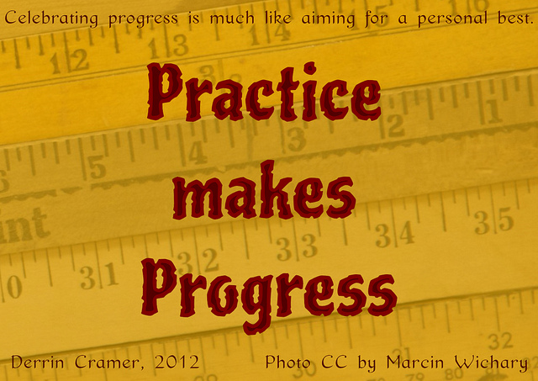 | 1 | 2  ADV 7:00 -8:00  Beg 8:00-8:45 | 3 | 4  Adv 8:30-9:30.  Beg 9:30-10:30 | 5 | 6
 | 7  Labor Day | 8 | 9  ADV 7:00 -8:00  Beg 8:00-8:45 | 10 | 11  Adv 8:30-9:30  Beg.9:30-10:30 | 12 | 13
 | 14 | 15 | 16  ADV 7:00 -8:00  Beg 8:00-8:45 | 17 | 18  Adv 8:30-9:30.  Beg.9:30-10:30 | 19 | 20
 | 21 | 22 | 23  ADV 7:00 -8:00  Beg 8:00-8:45 | 24 | 25  Adv:30-9:30  Beg.9:30-10:30 | 26 | 27
 | 28 | 29 | 30  ADV 7:00 -8:00  Beg 8:00-8:45 | ---- | 2  Adv 8:30-9:30  Beg.9:30-10:30 | ---- | ----
Columbia/ Terra Linda
ORCHESTRA
.

